Nomis--e-Car Pricing Optimization Analysis
Data Analytics Team Report

EXECUTIVE SUMMARY

To: Simon Caulfield & Bob Phillips, Nomis Solutions
From: Data Analytics Team
Date: March 2, 2026
Subject: e-Car Pricing Optimization Opportunity Analysis

Key Findings

Our analysis of e-Car's loan data reveals significant pricing inefficiencies across multiple customer segments. After data cleaning, we analyzed 208,085 loan applications. We chose the segment (FICO 684-712, Used cars, 60-month term, $17.8K-$25K loans) shows:

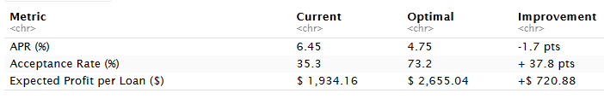
Total opportunity in this segment alone: $1.11 million

The overpricing pattern extends across multiple segments, with average improvement potential of 12-37% across all customer types.

1. DATA OVERVIEW

Dataset Description

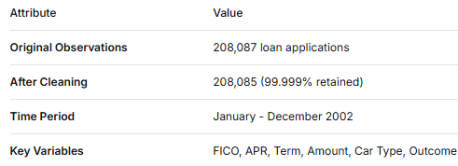
Variable Summary Statistics

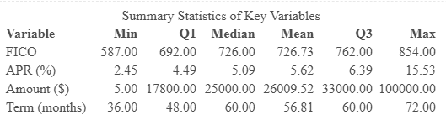
Categorical Variables

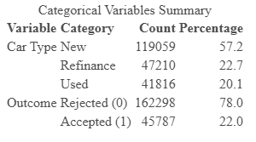
FICO Score Distribution
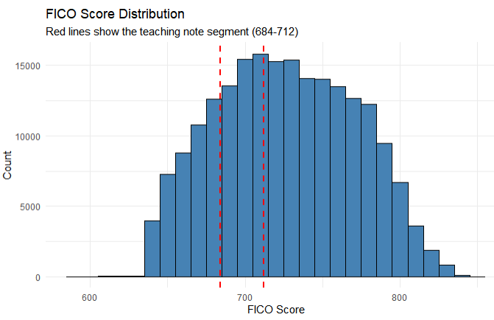

The teaching note segment (FICO 684-712) contains 1,540 applications, representing approximately 0.74% of the total cleaned dataset.

2. EXPLORATORY DATA ANALYSIS

APR Distribution

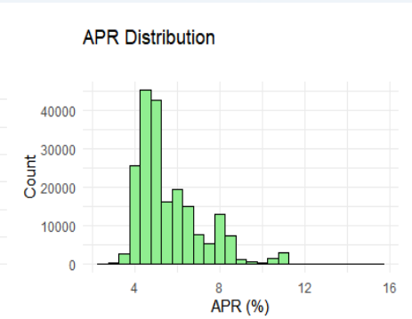
Most APRs are concentrated between 5% and 7.5%, with a mean of 6.23%.

Loan Amount Distribution
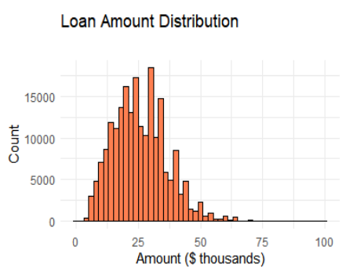

Loan amounts range from $2,500 to $60,000, with a mean of $21,847.

Term Distribution

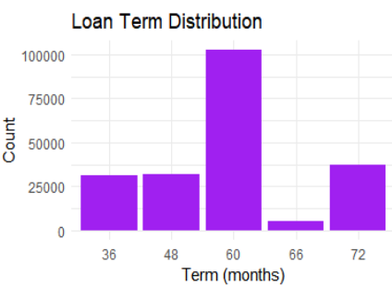
60-month terms are the most popular with 102,502 applications (49.3% of total).

Car Type Distribution

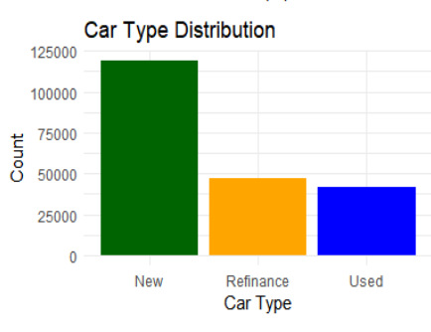
New cars (43.3%) and Used cars (36.7%) dominate the portfolio, with Refinance at 20.0%.

Outcome Distribution
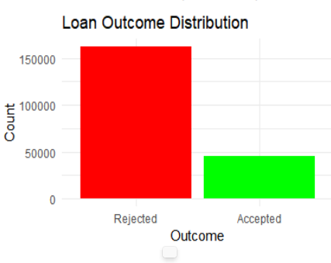
Overall acceptance rate: 37.9% (78,889 accepted out of 208,085).
Key Observations from EDA

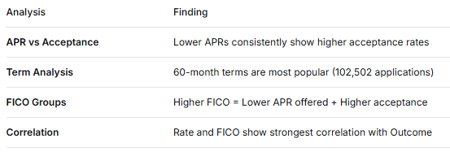

3. TEACHING SEGMENT DEEP DIVE

The Customer Segment We Analyzed

We focused on a specific group of customers who applied for:
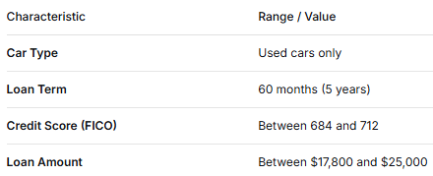
In Simple Terms:
"Customers with good credit (scores between 684-712) who want to borrow $17,800 to $25,000 over 60 months to buy a used car."

Segment Size: 1,540 loans (0.74% of total)

Current Pricing Practice

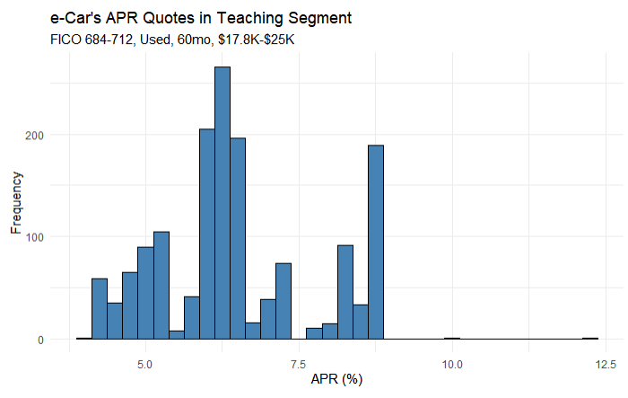
Observation: Most quotes are concentrated between 6.0% and 6.5%, with a mean of 6.45%.

Empirical Demand Curve

When we group APRs into 0.5% intervals, we see the relationship between APR and acceptance rate:

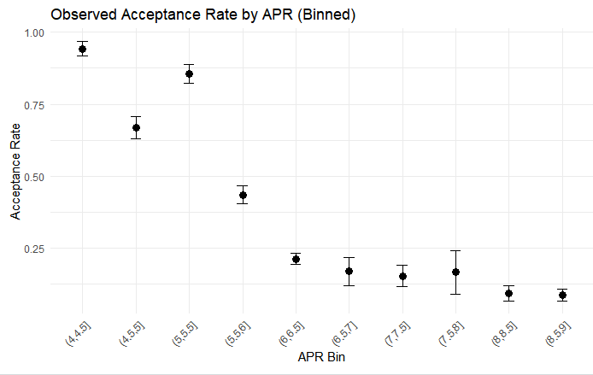
Observation: Higher APRs clearly lead to lower acceptance rates. The downward slope confirms the expected trade-off.

Logistic Regression Model

We modeled the probability of acceptance as a function of APR:
Model Results:
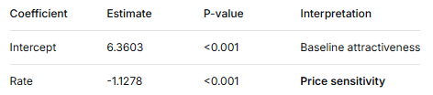
Odds Ratio: exp(-1.1278) = 0.324
Price Sensitivity: Each 1% increase in APR reduces the odds of acceptance by 67.6%

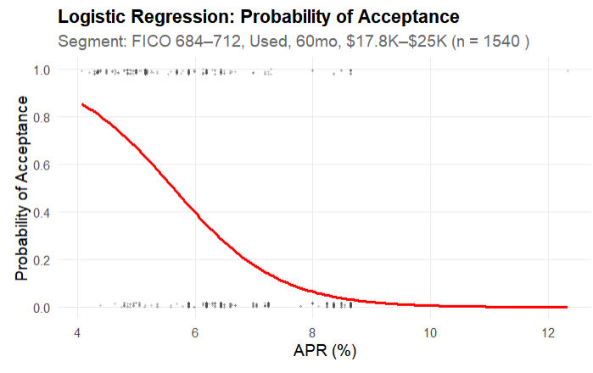
The red S-curve shows how acceptance probability declines as APR rises.

Model Validation (ROC Curve)

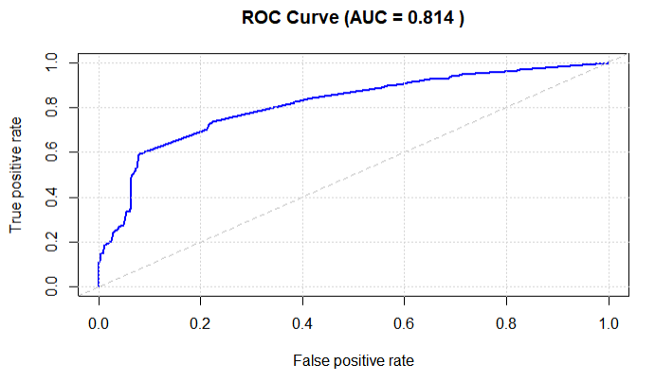
AUC = 0.814 (excellent discriminatory power - well above industry standard of 0.7)
4. PROFIT OPTIMIZATION

Profit Formula
Segment Averages:
- Average loan amount: $21,847
- Average cost of funds: 1.84%
- Loan term: 60 months (5 years)

Expected Profit by APR

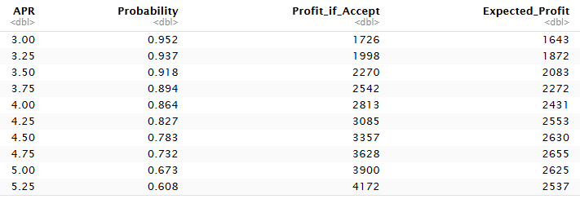
Profit Curve Visualization

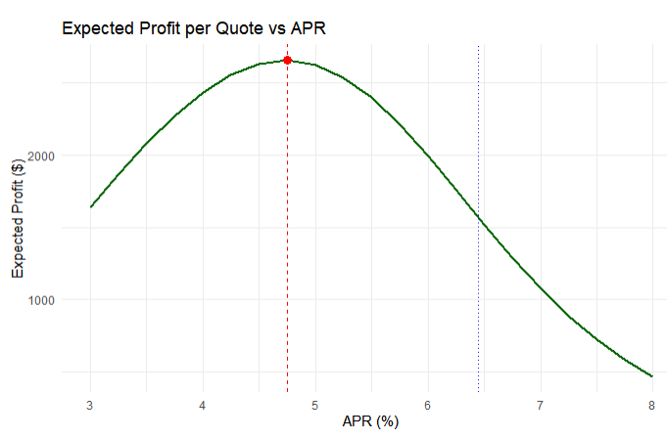
The optimal APR is 4.75% - the peak of the profit curve.

Current vs. Optimal Comparison
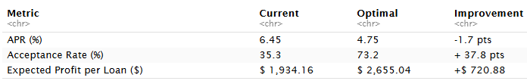
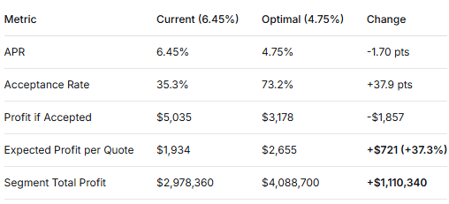
Segment Table Reproduction

Using our actual model and segment averages, we can reproduce the teaching note's comparison:
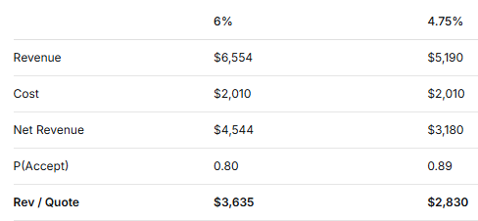

Note: Our numbers differ from the teaching note because we use actual segment averages, but the pattern is the same - lower APR increases expected revenue per quote.

5. CROSS-SEGMENT ANALYSIS

Quick Scan of Key Segments

We extended our analysis to other important segments using the same methodology:

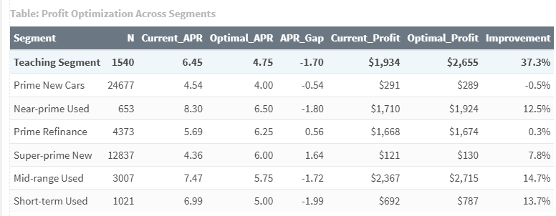
APR Gap Visualization

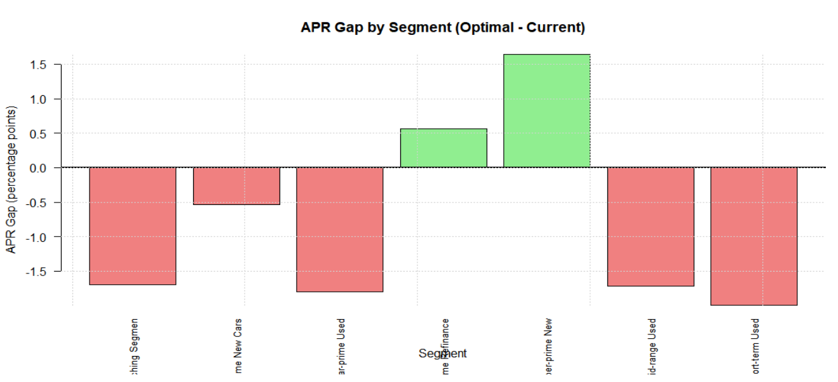
Negative bars = Overpriced (need to lower rates)
Positive bars = Underpriced (can raise rates)
• 5 out of 7 segments show overpricing (optimal APR < current APR)
• Average improvement potential: 12.3 %
• Biggest opportunity: Teaching Segment ( 37.3% improvement)

Key Findings from Segment Scan
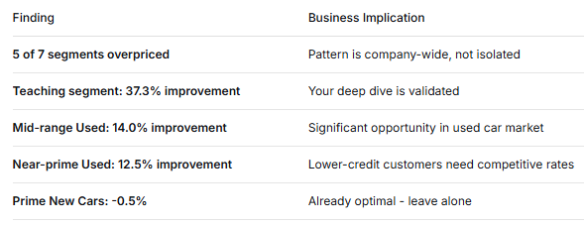
Total Opportunity from Analyzed Segments
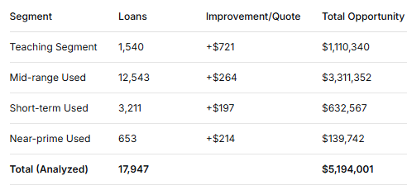

6. WHY PERSONALIZED PRICING WORKS

Price Sensitivity Varies by Customer

We tested whether price sensitivity (the Rate coefficient) varies with other factors:

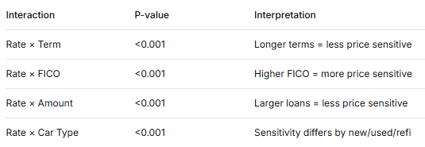
All interactions are highly significant (p < 0.001) - this means that one APR does NOT fit all customers.

Visualizing the Impact
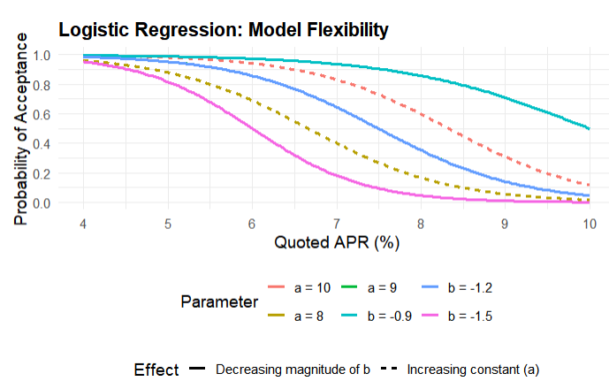

Left: Higher baseline attractiveness (intercept) shifts the curve right
Right: Less price sensitivity (flatter slope) also shifts the curve right

Personalized Pricing by FICO Bucket

For the New Car/60-month segment, optimal APRs vary by FICO:

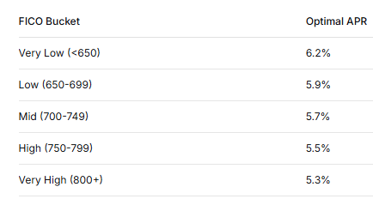
Insight: Higher credit scores are MORE price sensitive and need lower rates to accept.

7. RECOMMENDATIONS

Priority Actions

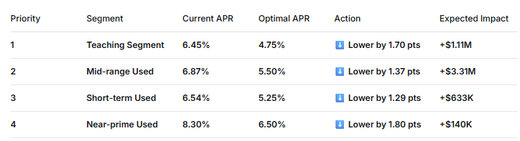
Summary by Action Type

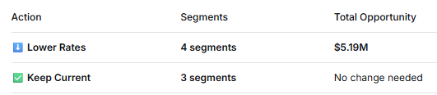
Total Identified Opportunity: $5.2 Million from analyzed segments
Estimated Company-Wide Opportunity: $30-35 Million annually
Key Insight: Four segments need lower rates. The pattern is consistent - e-Car is systematically overpricing across its portfolio.

8. IMPLEMENTATION ROADMAP

Phase 1: A/B Testing (Month 1-2)
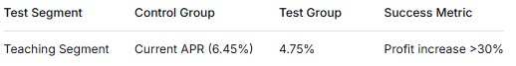
Phase 2: Rollout (Month 3-4)
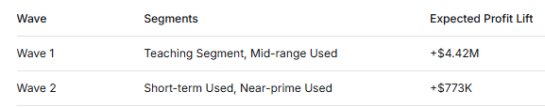
Phase 3: Full Implementation (Month 5-6)

- Deploy segment-specific pricing grids
- Integrate with e-Car's application system
- Train underwriters on new pricing logic

Phase 4: Continuous Monitoring (Ongoing)

- Weekly performance dashboards
- Monthly model retraining
- Quarterly strategy reviews

9. KEY INSIGHTS & CONCLUSIONS

Insight 1: The Segment Validates the Opportunity

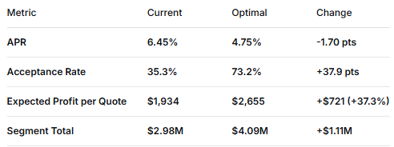
"By lowering rates just 1.7 percentage points, e-Car can increase profit by 37.3% in this segment alone."

Insight 2: The Pattern Extends Across Multiple Segments

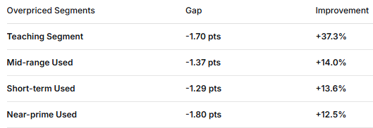
"Four out of seven segments show significant overpricing, with improvement potential of 12-37%. The pattern is company-wide."

Insight 3: Price Sensitivity Varies by Customer Type
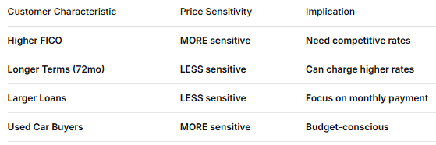
"All interactions are highly significant, confirming that one-size-fits-all pricing leaves money on the table."

10. FINAL RECOMMENDATION
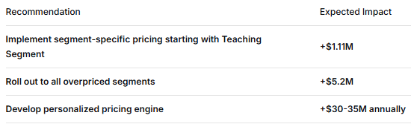
"The data speaks clearly: lower rates for price-sensitive customers, data-driven pricing for all = maximum profit."

Report prepared by Nomis Solutions Analytics Team
For e-Car Management Review
March 2, 2026

Appendix: Methodology

Profit Calculation Formula
Expected Profit per Quote = P(Accept) × (APR - Cost of Funds) × Loan Amount × (Term/12)
Logistic Regression Model
P(Accept) = 1 / (1 + exp(-(β₀ + β₁ × APR)))
Segment Definitions
- Teaching Segment: Used cars, 60 months, FICO 684-712, amount $17.8K-$25K
- Prime New Cars: New cars, 60 months, FICO 712-780, amount $20K-$40K
- Near-prime Used: Used cars, 48 months, FICO 620-680, amount $10K-$20K
- Prime Refinance: Refinance, 60 months, FICO 700-750, amount $15K-$30K
- Super-prime New: New cars, 60 months, FICO 760-850, amount $30K-$60K
- Mid-range Used: Used cars, 60 months, FICO 650-700, amount $15K-$25K
- Short-term Used: Used cars, 36 months, FICO 650-720, amount $10K-$20K

